**Impact of Ion Transport on Membrane Scaling in Bipolar Membrane Electrodialysis**

Yuqin Nia,b, She Qianhonga,b,*

1. School of Civil and Environmental Engineering, Nanyang Technological University, Singapore 639798, Singapore
2. Singapore Membrane Technology Centre, Nanyang Environment & Water Research Institute, Nanyang Technological University, Singapore 637141, Singapore

* Corresponding Author. Email address: qhshe@ntu.edu.sg

Abstract

Bipolar membrane electrodialysis (BMED) is an emerging technology for producing acid and base from salt solutions. However, the presence of divalent cations, such as Ca2+ and Mg2+, can lead to scaling through reactions with hydroxide ions (OH-), posing a significant operational challenge. This study provides a mechanistic understanding of scaling formation in BMED systems treating seawater brine. Scaling was observed in multiple locations, including the chambers and on bipolar membrane (BPM) and both sides of the cation exchange membrane (CEM). Initially, divalent cations migrated through the CEM and reacted with excess OH⁻ in the base chamber (BC), resulting in scale formation on the CEM facing BC. The accumulated scaling reduced the effective membrane area, increasing the local current density. Once the local current density exceeded the limiting current density, water splitting was triggered, generating additional OH-. OH- leaked into the seawater brine chamber (SC), where further water splitting and scaling occurred on the CEM facing the SC. In addition, scaling on BPM was attributed to the interaction between divalent cations and the locally elevated OH- concentration. These findings elucidate the evolution of scaling in BMED and provide insights for its mitigation in brine treatment applications.

**Keywords:** Bipolar membrane electrodialysis (BMED); Seawater brine treatment; Scaling formation

TOC Graphic

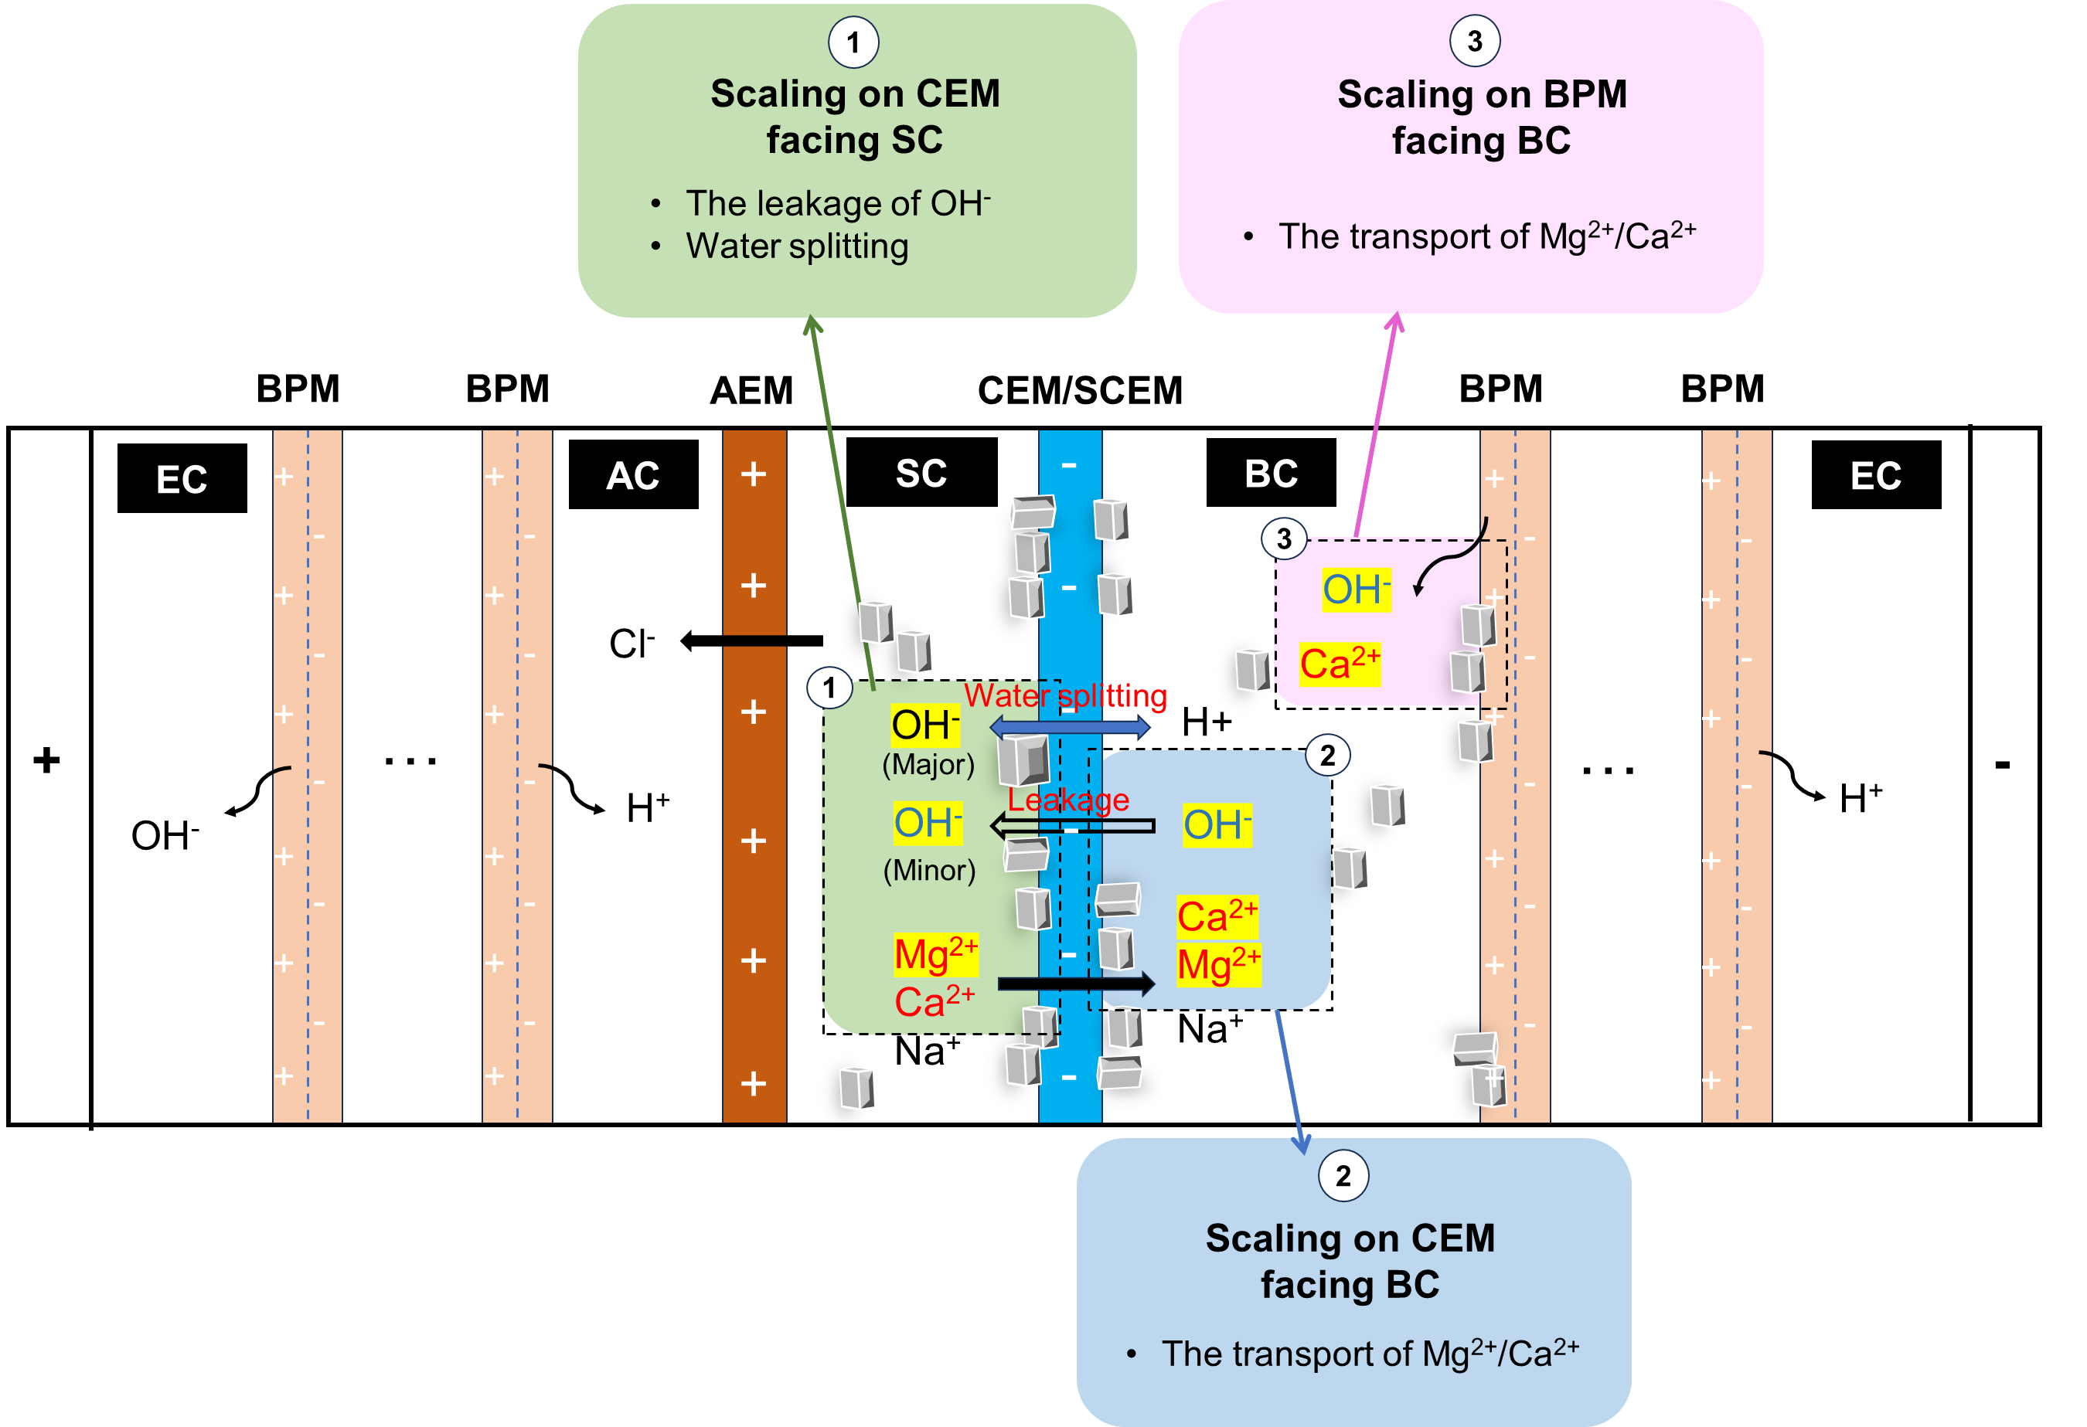

**Synopsis**

The transport behaviors (including ion migration, water splitting and OH- leakage) induce scaling in the solutions and across different membrane interfaces.

1. Introduction

In conventional chemical processes, high-salinity wastewater often arises as a byproduct of acid-base neutralization reactions. The direct discharge of brine solutions not only damages the environment1-3 but also leads to the loss of valuable resources2, 4-6. Therefore, the effective treatment of such waste brine solutions has become an urgent and critical issue. Among various treatment methods, electrodialysis (ED) has been widely employed to concentrate brine solutions, facilitating subsequent crystallization into solid salts 7-9. However, the economic viability of salt recovery via ED is not always favorable 10. To address this limitation, bipolar membrane electrodialysis (BMED) has been developed as an advanced electrochemical separation technology that combines the principles of ED with the unique properties of bipolar membranes (BPMs) 10-13. This approach enables the production of acids and bases from salt solutions, providing an efficient and environmentally sustainable alternative to conventional chemical processes. BMED has been applied in various biological and chemical industries 14-17. Many studies have shown that BMED has the potential to produce high-purity acids (e.g., HF,18 HNO310, HCl19, H2SO420, H3PO421, acetic acid22, citric acid23) and bases (e.g., NaOH21, 24, LiOH19) from salt solutions.

One of the most critical challenges in BMED is the formation of scaling on ion exchange membranes (IEMs) 25, 26. Scaling adversely affects BMED by reducing ion flux, increasing membrane resistance, and elevating energy consumption26-28. As scaling progresses, it can cause irreversible damage to membranes, especially increasing the risk of membrane rupture 29. Generally, scaling is affected by solution composition, process parameters and IEM properties. Bazinet, et al. 30 and Wang, Yang and Cong 27 found scaling on cation exchange membranes (CEMs) when feeding solution contained Ca2+ and Mg2+. Casademont, et al. 31 found that an alkali feeding solution triggered scaling on CEMs. The presence of multivalent ions (e.g., Ca2+ and Mg2+) in feeding solution predominantly results in scaling as they react with hydroxide ions (OH⁻) within the chambers to form sparingly soluble precipitates 25-27, 30. Many other studies studied the process parameters, such as flow rate32 and current density32, 33. A high flow rate can enhance mixing near membrane/solution interface to avoid ion accumulation. In terms of current density, it is related to ion flux, which causes pH shifts near membrane surface and scaling growth. Some studies link the scaling behavior with properties of IEMs, including ion selectivity14, heterogeneity34, 35, and membrane roughness35, 36. These studies tried to change surface properties of membranes to avoid scaling accumulation.

Scaling in BMED is an unavoidable problem because of the presence of base chamber. Previous studies have primarily focused on removing divalent ions prior to BMED treatment using pretreatment such as nanofiltration37, chemical precipitation37, ion exchange resins 19, pellet reactor 26. While these strategies reduced the incidence of scaling, they often introduce additional complexity and cost. Moreover, they do not consider that more efficient methods can be designed according to scaling mechanisms on different location. Therefore, a mechanistic understanding of how scaling evolves—particularly how ion transport behaviors interact with scaling processes—needs to be explored. Currently, no studies have provided a comprehensive analysis of the precipitation sequence in different chambers and on the IEMs.

The objective of this study is to elucidate the mechanism of scaling formation throughout the BMED process, with a focus on the interactions between ion transport and scaling development. The influence of scaling on BMED performance and efficiency was discussed to explain the significance of the study. The scaling in the chamber and on IEMs was characterized to ensure the location where scaling took place and its composition. In the BMED process, the system parameters were monitored to explain the scaling evolution. By providing a mechanistic framework, this study offers insights into future strategies for effective mitigation and operational optimization.

1. Material and Methods
   1. Lab-scale BMED Stack and Membranes

Commercial ion exchange membranes (IEMs) were used in this study. The bipolar membranes (BPMs) were CJBPM-1 (Kejia Polymer Materials Technology Co., China), while the CEMs and anion exchange membranes (AEMs) were CSE and ASE, respectively (ASTOM Co., Japan). The effective membrane area was 7.065 cm2.

The configuration of the lab-scale BMED stack was illustrated in **Figure S1**. The stack contained three repeating units, each consisting of one BPM, one AEM, and one CEM. An additional BPM was placed adjacent to the cathode. The complete assembly comprised two electrode chambers (ECs), three acid chambers (ACs), three salt chambers (SCs), and three base chambers (BCs). Each chamber had a thickness of 1 cm.

* 1. **Protocol**

A closed-loop circulation system was employed due to the low current density used in the experiments38. The setup consisted of four independent solution circuits: salt solution, base solution, acid solution, and electrode rinsing solution. The seawater brine (SWB) was prepared by doubling the concentration of synthetic seawater39, with the detailed composition provided in **Table S1**. For comparison, a NaCl solution with equivalent conductivity to the SWB was used as a baseline system in the absence of scaling. The BC and AC were initially filled with 10 mM NaOH and 10 mM HCl, respectively. The electrode rinsing solution was 0.3 M Na2SO4. The volume of each solution was 0.4 L. Two peristaltic pumps (Lead Fluid, BT-600L-2 × YT15, China) maintained a constant flow rate of 200 mL/min through the respective chambers. Titanium electrodes coated with ruthenium served as the anode and cathode. A constant current mode was adopted to ensure higher acid/base production rates and improved ion permselectivity 40. The applied current density was maintained at 15 mA/cm² using a DC power supply (A-BF SS-L603SPD, China). Each experimental run lasted for 9 hours and was repeated at least three times to ensure reproducibility.

Prior to applying the current, the system was operated for 10 minutes to remove air bubbles, ensuring complete wetting of the membrane surfaces and minimizing potential performance disturbances.

* 1. **Scaling Characterization and BMED Performance Analysis**
     1. Scaling Characterization

Characterizing membrane scaling was essential for visualizing deposits morphology and determining elemental composition. Field-emission scanning electron microscopy (FESEM; JEOL-7200F, Japan) and energy-dispersive X-ray spectroscopy (EDX; Oxford Instruments Aztec Standard X-max 50, UK) were employed to examine membrane surfaces. Additionally, precipitated solids collected after BMED operation were analyzed using X-ray diffraction (XRD; Bruker D8) to identify crystalline phases.

To assess the extent of scaling within the chambers, turbidity measurements were performed on the salt and base solutions. 30 mL of solution were sampled from the SC and BC both before and after the experiments. Turbidity was measured using a laboratory turbidimeter (2100N IS, HACH), with each sample analyzed in triplicate for accuracy.

In addition to qualitative characterization, quantitative analysis was conducted to evaluate scaling severity. The calcualtion of reduction ratio of Ca²⁺ and Mg²⁺ ($R_{{Ca}^{2+}}$, $R_{{Mg}^{2+}}$, %) and mass of scaling ($m_{scaling-Ca}$, $m_{scaling-Mg}$, mg) was shown in **Supporting Information S3**.

* + 1. **BMED Performan**ce Analysis

Key operational parameters—including voltage, current, and pH—were continuously monitored to assess BMED performance and ensure system stability. Conductivity changes in AC, BC and SC were recorded every five minutes using conductivity meters (Orion Star A212, Thermo Scientific, USA). Current and voltage data were recorded every minute using Power DC software. The pH in the AC, BC, and SC was measured using a portable pH meter (Seven2Go pH/Ion Meter S8, Mettler Toledo, Singapore). Additionally, 0.5 mL samples were periodically collected from each chamber to quantify the concentration of divalent ions (i.e., Ca²⁺ and Mg²⁺) using inductively coupled plasma optical emission spectroscopy (ICP-OES, Vio 550Max, PerkinElmer).

The stack resistance ($R_{stack}$, Ω) was calculated according to Ohm’s Law with **Eq. 1**.

$$\begin{aligned}R_{stack}=\frac{U_{t}}{I_{t}}\#\left(1\right)\end{aligned}$$

Where $U_{t}$ was the voltage (V) and $I_{t}$ was the current (A) at time $t$.

The stack resistance is the sum of electrode resistance, chamber resistance, and membrane resistance 39, 41. The electrode resistance ($R_{ele}$) was 43.11 Ω tested by the setup shown in **Figure S2** and calculated from **Figure S3** (details in **Supporting Information S4**). The chamber resistance ($R_{chamber}$, Ω) was calcualted by **Eq. 2**41.

Where is the number of repeating units, $A$ is the effective membrane area (m2). , , were the thickness of AC, BC and SC (m), $σ_{AC}$, $σ_{BC}$ and $σ_{SWBC}$ is the conductivity of AC, BC and SC (S/m).

The membrane resistance ($R_{membrane}$, Ω) was calculated by **Eq. 3**.

$$\begin{aligned}R_{membrane}=R_{stack}-R_{chamber}-R_{ele}\#\left(3\right)\end{aligned}$$

1. Results and Discussion
   1. Characterization of scaling in BMED treating SWB

After BMED tests, IEMs and solutions were characterized by FESEM and turbidimeter to analyze the formation location and chemical composition, respectively. When treating NaCl, no precipitate was visually inspected using photographic evidence (**Figure 1 a1, b1, c1, d1**) and FESEM (**Figure S6 a1, b1, c1, d1**). For BMED of SWB, although no scaling was observed on AEM facing SC **(Figure 1 a2-3**), precipitates was observed on both sides of the CEM (**Figure 1 b2-3 and c2-3**) and BPM facing BC (**Figure 1 d2-3**) after BMED treating SWB, suggesting the formation of scaling on the CEM and BPM. Moreover, compared with tests for NaCl (**Figure S4 a1 a2**), SC and BC became visibly turbid when processing SWB **(Figure S4 b1 b2)**. The turbidity of solution in the SC increased from 0.137 to 45.233 NTU and that in the BC increased from 0.112 to 29.4 NTU (**Table S2**), which also proved that suspended particles were formed in the tests.

The EDX results, which revealed the elemental distribution on membranes after BMED treatment of NaCl and SWB, were consistent with the observed scaling during operation. Since no scaling observed on the AEM after BMED of SWB, no Mg and Ca distribution was observed (**Figure 1 a4-a5**) and the atomic ratios of carbon and oxygen (**Figure 1 a6**) was similar as the pristine AEM (**Figure S5 a**). Compared to the pristine CEM (**Figure S5 b**), clear Ca and Mg distributions were observed on both sides of the used CEM in BMED of SWB (**Figure 1 b4-b5** and **Figure 1 c4-c5**). The atomic percentage of Mg and Ca increased from ~0 to ~9 % (**Figure 1 b6, c6**).In contrast, only Ca distribution was observed on the surface of BPM (**Figure 1 d4-d5**). 1.8% Ca was detected on the BPM facing BC while the composition of Mg remained zero (**Figure 1 d6**) compared to the pristine BPM (**Figure S5 c**), which will be discussed in detail in the next section.

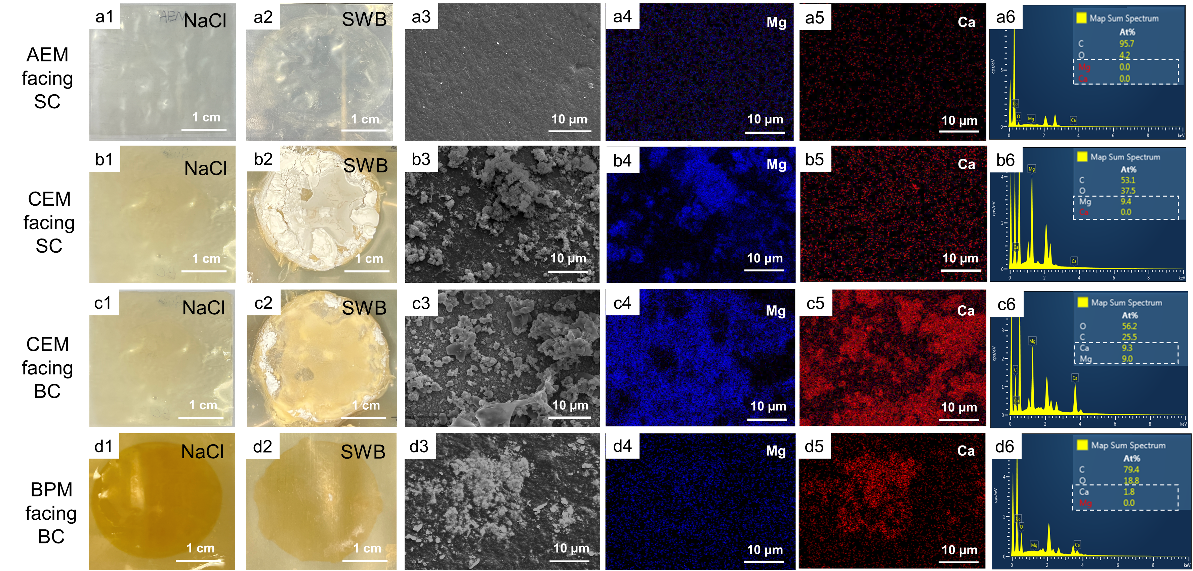

Figure 1 SEM and EDX elemental analysis of membrane surfaces. AEM facing SC: Photograph after tests in (a1) NaCl and (a2) SWB; (a3) SEM diagram; EDX elemental mapping image of (a4) Mg and (a5) Ca; (a6) EDX map spectrum. CEM facing SC: Photograph after tests in (b1) NaCl and (b2) SWB; (b3) SEM diagram; EDX elemental mapping image of (b4) Mg and (b5) Ca; (b6) EDX map spectrum. CEM facing BC: Photograph after tests in (c1) NaCl and (c2) SWB; (c3) SEM diagram; EDX elemental mapping image of (c4) Mg and (c5) Ca; (c6) EDX map spectrum. BPM facing BC: Photograph after tests in (d1) NaCl and (d2) SWB; (d3) SEM diagram; EDX elemental mapping image of (d4) Mg and (d5) Ca; (d6) EDX map spectrum. (AC: acid chamber; SC: salt chamber; BC: base chamber; SWB, seawater brine).

Powders from scaling experiments were collected for XRD analysis to identify the type of scaling (**Figure S7**). The appeared peaks showed the presence of Mg(OH)2 in the form of brucite crystals, Ca(OH)2 in the form of portlandite, and CaCO3 in the form of calcite. The formation of Mg(OH)2 and Ca(OH)2 was due to the reaction of divalent ions and the produced OH- (Ksp = 1.8 × 10-11 for Mg(OH)2 and Ksp = 6 × 10-6 for Ca(OH)2 at 25 ℃) 34, 42, 43. As there was NaHCO3 in SWB, it reacted with OH- and transferred to CO32- in SC, which further reacted with Ca2+ to form CaCO3 (Ksp = 4.7 × 10-9 for CaCO3). The above XRD results consisted with the EDX results which showed the increase in the Mg and Ca element on membrane surfaces with scaling.

* 1. **Scaling mechanism in BMED treating SWB**

To gain a deeper understanding of the observed scaling behavior, this section will delve deeper into the potential mechanisms of scaling within the BMED stack.

* + 1. pH changes and divalent cation loss

According to the elemental results of scaling, we measured pH changes (i.e., the concentration of OH-) and scaling precursors (i.e., Ca2+ and Mg2+) in the BMED system to better understand the mechanism of scaling.

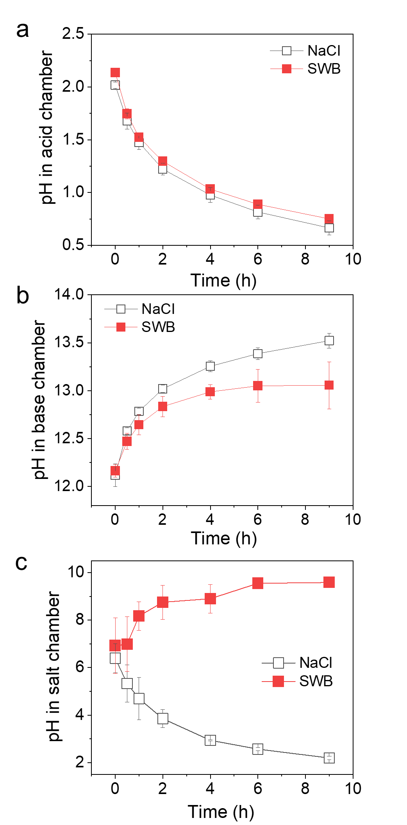

Figure 2 pH changes in the (a) acid chamber; (b) base chamber; (c) salt chamber with time.

**Figure 2 a, b** shows that the pH of the AC remained below 2, while that of the BC exceeded 12 throughout the BMED process for both NaCl and SWB. In contrast, the SC exhibited distinct pH trends depending on the feed composition. When NaCl was used, the pH in the SC decreased from 6.39 to 2.19, indicating acidification. However, when SWB was treated, the pH of the SC increased and remained above 9 after 4 hours. The gaps between the pH values of the AC and BC, as well as the opposite pH trends in SC, will be discussed in detail in a later section.

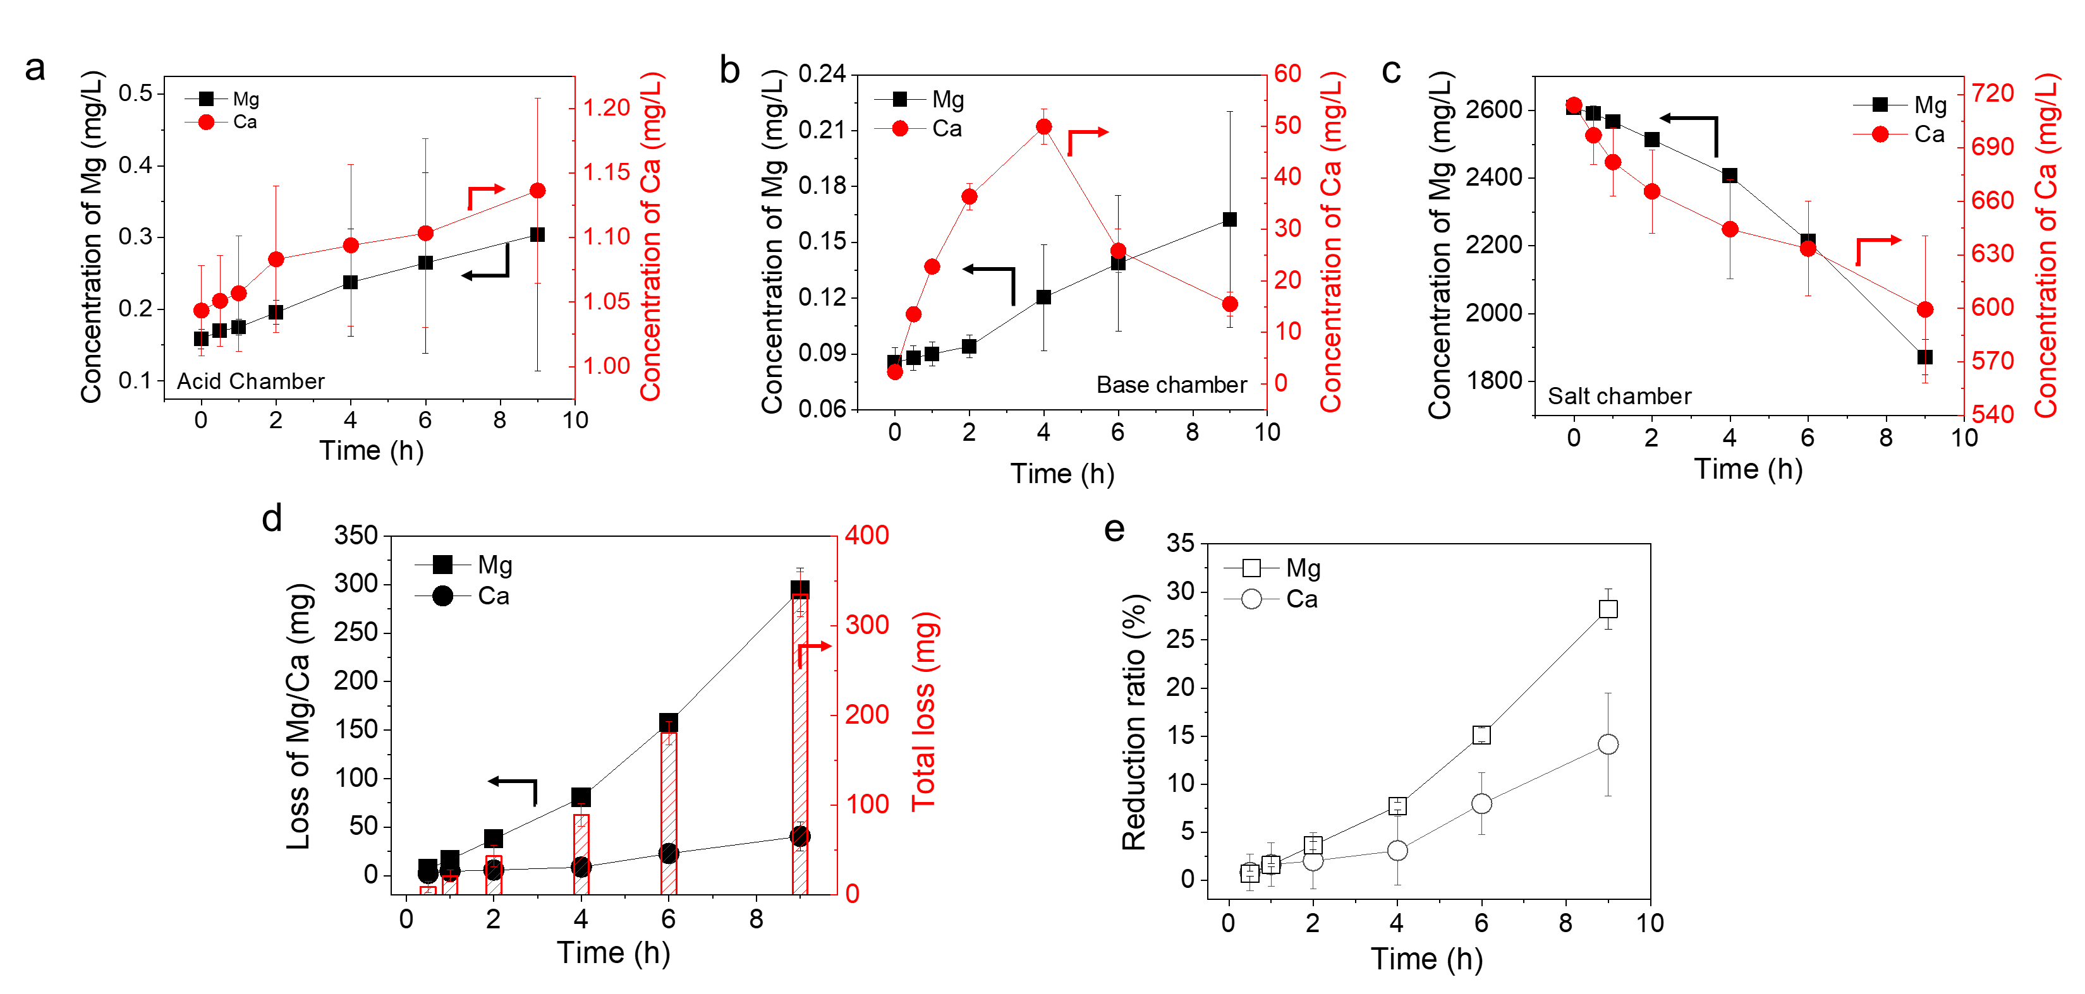

Figure 3 The concentration changes of Mg2+ and Ca2+ in (a) AC, (b) BC and (c) SC. (d)The loss and (e) reduction ratio of Mg2+ and Ca2+ with time.

The concentration changes of scaling precursors (Mg2+ and Ca2+) in different streams were measured and their loss was further analyzed during BMED using SWB. The concentrations of scaling precursors in AC and BC kept in a lower range than that in SC (**Figure 3 a, b, c**). The concentration of scaling precursors slightly increased in the AC and gradually decreased in the SC. In the BC, the concentration increased as well, while there was an up-down trend for Ca2+. To better quantify scaling, the element loss of scaling precursors was calculated (**Figure 3 d, e**). After tests, the loss of Ca gradually increased to 40.56 mg **(Figure 3 d**), corresponding to 14.15% reduction ratio (**Figure 3 e**). Similarly, the loss of Mg started as soon as the experiment began and reached 294.55 mg and reduction ratio of 28.23% at the end (**Figure 3 d, e**). Finally, the total scaling increased to 335.11 mg (**Figure 3 d**).

The loss can be explained by the following reactions:

$$\begin{aligned}{Mg}^{2+}+2{OH}^{-}→Mg{\left(OH\right)}_{2}↓\#\left(4\right)\end{aligned}$$

$$\begin{aligned}{Ca}^{2+}+2{OH}^{-}→Ca{\left(OH\right)}_{2}↓\#\left(5\right)\end{aligned}$$

$$\begin{aligned}{Ca}^{2+}+{HCO_{3}}^{-}+{OH}^{-}→CaCO_{3}↓\#\left(6\right)\end{aligned}$$

The low concentration of OH- and divalent cations in the AC (**Figure 2a and 3a**) explained the clean AEM membrane surface after BMED using SWB (**Figure 1 a2-a6**). Since the concentration of OH- in the BC was high, the concentration of Mg2+ in the BC kept in relatively low range due to **Eq. 4**. However, the concentration of Ca2+ initially increased to 49.95 ppm in 4 hours and then decreased to 15.53 ppm at the end, suggesting more severe scaling of Ca(OH)2 through **Eq. 5**. Similarly, **Eq. 4-6** occurred in the SC because of the high concentration of scaling precursors (**Figure 3 c**) and gradually increased pH (**Figure 2 c**). The pH of SWB reached 9 at 4 hours (**Figure 2 c**), and the concentration of Mg exhibited a steeper decrease at the same time (**Figure 3 c**). Scaling in different parts of the stack will be discussed in detail in the following sections.

* + 1. Scaling formation in the solution

Scaling in the bulk solution can occur due to two main mechanisms. The first involved scaling that initially formed on the surface of IEMs and then detached into the bulk solution 35, 36. The fluctuation of voltage (**Figure S8**) illustrated the detachment and regrowth of scaling. The surface of IEMs was smooth, and scaling grew on the membrane surface. Scaling was easy to detach from the IEM surface, which resulted from the decrease of voltage. When a new scale layer grew, the voltage increased again. Once the scaling shredded from surface to the bulk solution, these particles not only contributed to visible turbidity but can also act as nucleation seeds, accelerating further crystallization in the solution44.

The second mechanism involved the direct crystallization within the bulk solution itself. When the concentration of scaling ions (Ca2+, Mg2+, OH- and CO32-) exceeded their solubility limits, scaling formed in the bulk solution (Ksp = 1.8 × 10-11 for Mg(OH)2 and Ksp = 6 × 10-6 for Ca(OH)2 at 25 ℃) 34, 36. During BMED, cations transported from the SC to the BC, resulting in the accumulation of cations with time. However, the solubility limits the distribution of ions in BC. As shown in **Figure 3 b**, the high concentration of OH- resulted in the low concentration of Mg2+. It also limited the concentration of Ca2+, which exhibited a rise followed by a decline. Furthermore, the concentration of scaling ions in SC provide evidence for solubility limits. In SC, the concentration of OH- increased with time and the pH reached 9 at 4 hours (**Figure 2 c**), accompanied by the sharper decrease in the concentration of Mg2+ (**Figure 3 c**).

* + 1. Scaling formation on CEMs

According to the membrane morphology detection, scaling would take place on both sides of the CEM. Each region demonstrated unique scaling behaviors influenced by local ion transport, OH⁻ generation and leakage.

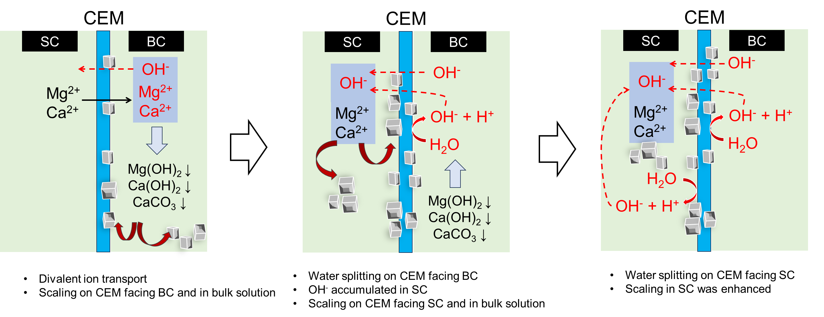

Figure 4 Schematic diagram of scaling formation mechanisms on CEM (SC, salt chamber; BC, base chamber; CEM, cation exchange membrane).

As shown in **Figure 4**, once the test began, cations including Ca2+ and Mg2+ transported across the CEM from SC to BC under the electric field. At the same time, the OH- ions generated from the BPM transported to the interface of CEM/BC. When Ca2+, Mg2+ and OH- appeared on the surface of the CEM facing the BC, scaling of Mg was generated on CEM due to lower solubility product, while Ca2+ was more likely to leave the CEM. Next step, as scaling covered the CEM surface (**Figure 1 c2**), the effective membrane area decreased and the local current density on the uncovered area increased 35, 39, 45, 46. When the local current density exceeded the limiting current density, water splitting occurred at the interface of CEM/BC35, 39, 46. The occurrence of water splitting generated H+ and OH- to carry current 39. OH- might leaked through CEM and accumulated at the interface of CEM/SC as OH- ions have an abnormally high mobility 47, 48. The phenomenon can be proved by the different trends of pH changes in the SC between BMED using NaCl and SWB. When no scaling occurred, the pH of SC decreased, while pH of SC for BMED using SWB kept increasing (**Figure 2 c**). Subsequently, the OH- reacted with Ca2+ and Mg2+ at the CEM surface facing SC. With the experiment proceeded, the scaling further decreased the effective membrane area and the ion flux, thereby inducing water splitting on CEM facing SC as well 39, 46. Then OH- generated due to water splitting further reacted with divalent cations and formed scaling. Eventually, a large amount of scaling was formed on CEM surface facing SC (**Figure 1 b2**).

Besides water splitting, the leakage of OH- across the CEM from BC to SC was also a potential reason. The counterion selectivity of the pristine CEM was 0.95 (**Figure S10**), indicating the leakage of OH- existed throughout the experiment. Additionally, the transport number of counter-ions of scaled CEM decreased to 0.91, indicating scaling also enhanced OH- leakage. The increase of leakage might result from the deformation of CEM, since there was no gasket covering the entire membrane. Moreover, the decreased Donan exclusion might also increase the leakage. Gou, et al. 49 found that the high binding energy between Ca2+ and fixed charge group of CEM (RSO3-) enabled part of Ca2+ retained in the membrane channel. It was consistent with the result in **Figure S10** that the transport number of CEM (Ca2+ type) and CEM (Mg2+ type) were a little lower than that of pristine CEM (Na+ type). When divalent ions retained in membrane channel. The fixed charges were occupied and the Donnan exclusion was weakened and allowed the transport of co-ion (OH-) more easily. Although scaling usually grew on the surface of homogeneous CEMs, whether scaling grew in the membrane channel should be considered. The cross-section of scaled CEM and BPM (**Figure S11**) was measured, and no obvious nanocrystal signal was detected under the scale of 1 μm. It may be necessary to use more sophisticated detection methods to observe whether this possibility exists, leading to deformation of the membrane channel.

* + 1. Scaling formation on BPMs

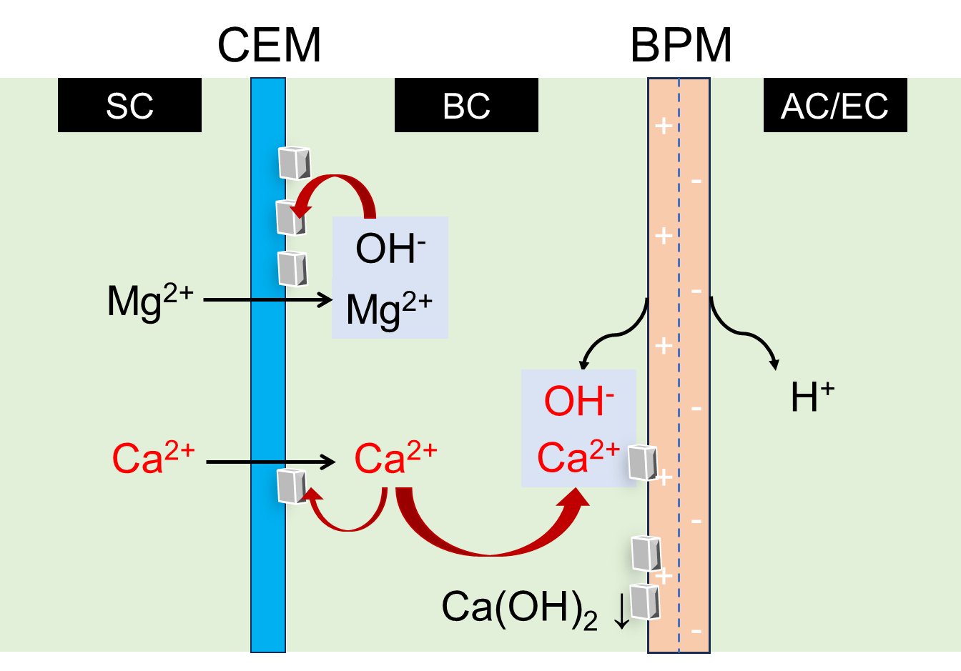

Figure 5 schematic diagram of scaling formation on BPM (SC, salt chamber; BC, base chamber; AC, acid chamber; EC, electrode chamber; CEM, cation exchange membrane; BPM, bipolar membrane).

**Figure 5** shows the scaling mechanism on BPM. Cations can transport through the BC to the BPM surface facing the BC. Once the divalent cations reached the interface of BPM/BC, scaling was generated due to the high OH- concentration at the surface. As shown in Figure 1 d3-d6, scaling on BPM was mostly composed of Ca2+. This can be explained by the low solubility of Mg(OH)2 (Ksp = 1.8 × 10-11)34. Mg2+ was preferentially deposited with OH- and nearly depleted in the BC (**Figure 3 b**). Thus, Mg2+ cannot reach the BPM surface. However, the initial increase of the concentration of Ca2+ in BC (**Figure 3 b**) shows the accumulation of Ca2+ in BC, indicating that Ca2+ can reach the BC/BPM interface under electric field. With the increase in the concentration of Ca2+ and OH- at the interface, more severe scaling occurred on BPM surface as indicated by the decrease in the concentration of Ca2+ (**Figure 3 b**).

* 1. **Influence of scaling on BMED performance and efficiency**

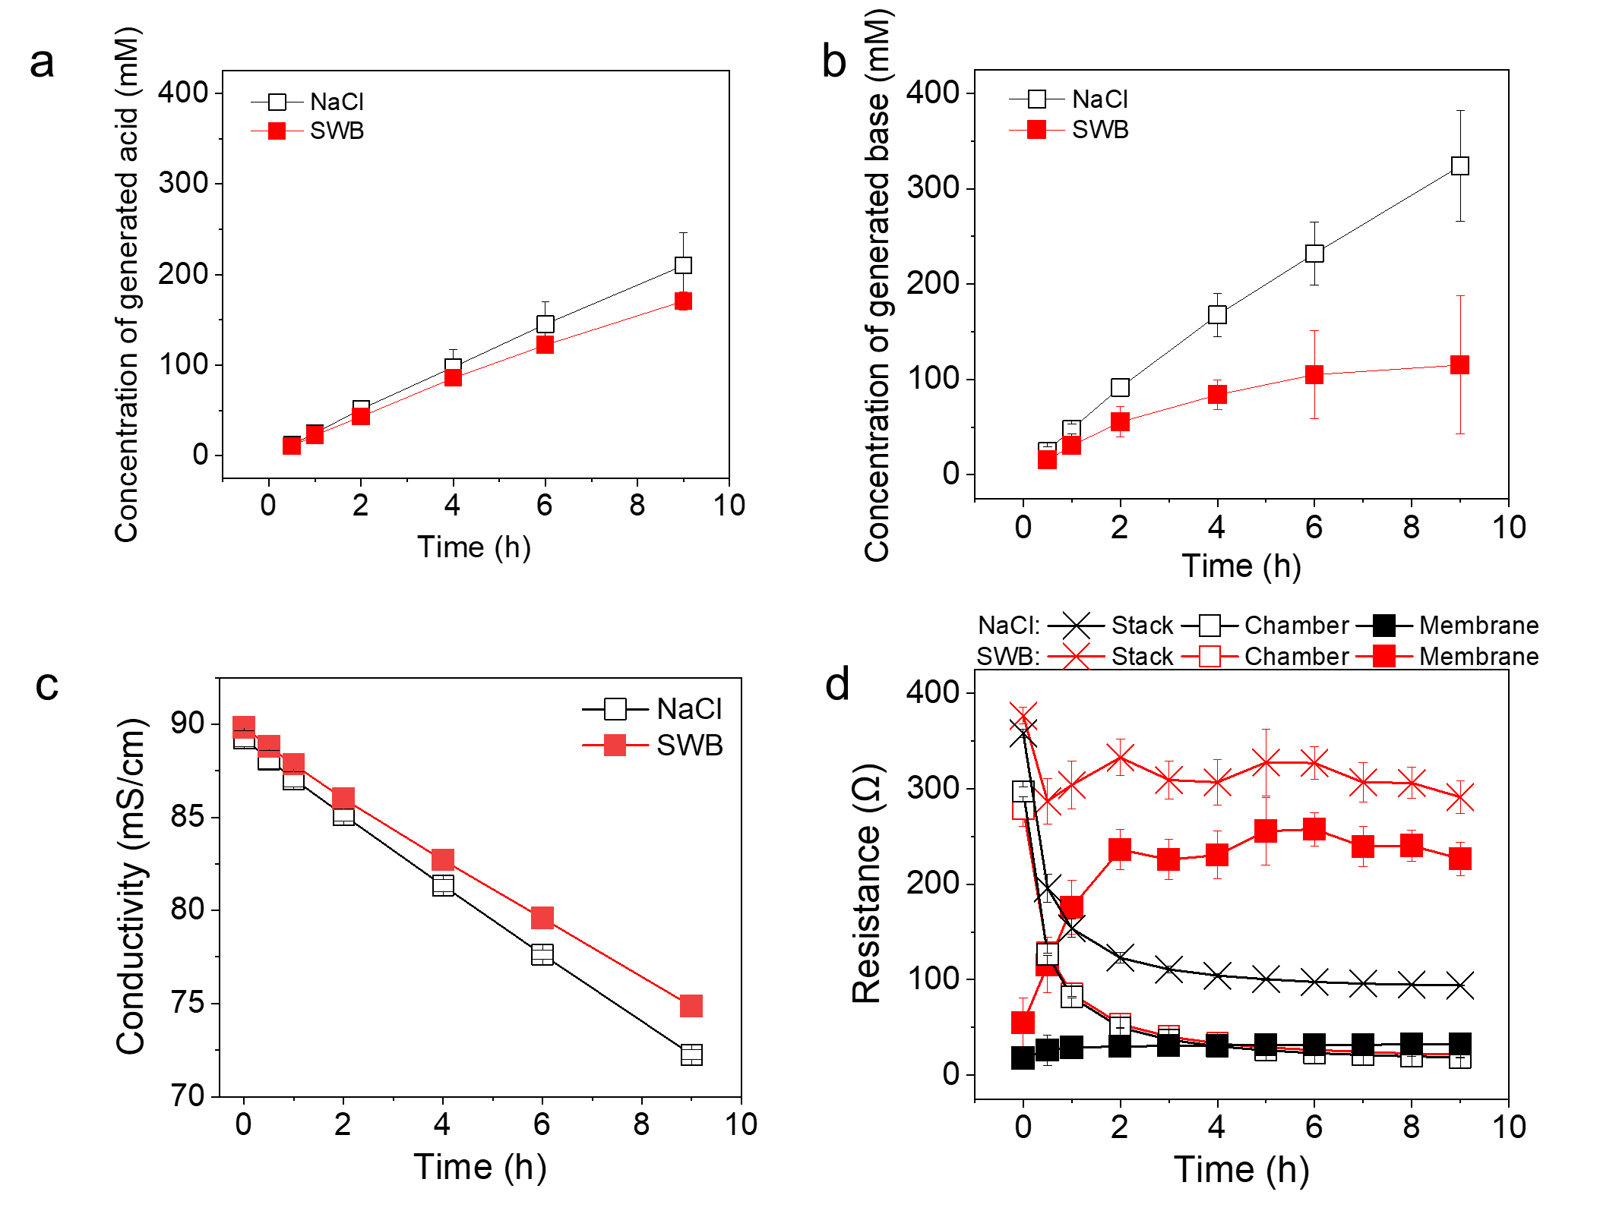

Figure 6 (a) The concentration of generated acid; (b) The concentration of generated base; (c) the conductivity change in the SC; (d) Variation of stack resistance, chamber resistance and membrane resistance during BMED treating different solutions.

Scaling seriously affected the BMED performance, including the concentration of product (**Figure 6a and 6b**), ion transport in the system **(Figure 6c**), the system resistance (**Figure 6d**), and energy consumption (**Figure S12**). As shown in **Figure 6a and 6b**, the concentration of generated acid was higher than that of base for SWB, while the trend is reversed for NaCl. The different trends can be explained by scaling. During BMED using NaCl, no scaling occurred. Due to the mobility difference50, H+ leakage was higher than OH- leakage, thereby resulting in the higher concentration of base (323.86 mM base > 210.03 mM acid). On the contrary, scaling during BMED using SWB consumed generated OH-, which decreased the concentration of base. Thus, the concentration of acid (170.74 mM) was higher than that of base for SWB (115.10 mM). In addition to consuming OH-, scaling also reduced base production by decreasing water dissociation at the BPMs and cation transport across the CEMs. Scaling on BPMs reduced the transport of water to the bipolar junction, which can decrease water dissociation51. Besides, scaling on CEMs reduced the transportation of cation. The conductivity of SC solution also agreed the difference between the final concentration for NaCl and SWB. As shown in **Figure 6c**, conductivity decreased by 16.65 % and 19.02% in 9 hours for SWB and NaCl, respectively. This can be attributed to the decrease in the effective membrane area on the CEM surface as discussed above. When scaling formed on the CEM surface, the transport of ions from SC was partially blocked by scaling, and water splitting occurred to form the H+ and OH- ions to carry current, which decreased the transport of ions from SC to BC.

Scaling also increased the system resistance (Figure 7d). As shown in **Figure 6d** and **Figure S8**, the stack resistance and voltage for SWB was higher than that for NaCl throughout the BMED tests. They were extremely high at the beginning of each test and subsequently decreased to a plateau for both NaCl and SWB. The high values at the beginning can be attributed to the initial low concentration solutions (0.01 M) used in AC and BC, which resulted in extremely high chamber resistance (**Figure 6d**). As BMED processed, the increase in acid and base conductivity (**Figure S13**) resulted in a sharp decrease in chamber resistance. Although chamber resistance decreased at the same rate over time for both NaCl and SWB, the membrane resistance exhibited different rates of increase. The membrane resistance for SWB increased to 226.71 Ω at the end, which was 85.9% higher than that treating NaCl (~32.36 Ω) (**Figure 6d**). The large gap between them can be attributed to the accumulation of precipitates on the membrane surface.

Accordingly, energy consumption increased with the decreased production of acid and base and increased stack resistance. As shown in **Figure S12**, the specific energy consumption of BMED using SWB (6.83 kWh/kg HCl and 13.11 kWh/kg NaOH) was higher than that using NaCl (3.59 kWh/kg HCl and 2.12 kWh/kg NaOH), i.e., 47.44 % higher for acid and 83.83 % higher for base.

Scaling can decrease the efficiency and lifespan of scaling elements and increase the requirement of regular cleaning and maintenance52-54. This work also performed tests and found that the membrane performance declined after the severe scaling in BMED treating SWB. As shown in **Figure S14**, the pH in SC increased, and the acid and base production decreased with scaled membrane. The change of pH of SC (decreased to 2.14 for pristine IEM, 2.25 for unscaled IEM, and 2.62 for scaled IEM at the end) indicated that the OH- leakage of scaled membrane increased (**Figure S14 a**). Moreover, the final acid concentration of scaled IEM was 167.59 mM (180.99 mM and 173.06 mM for pristine IEM and unscaled IEM, respectively), and the final base concentration of scaled IEM decreased to 208.02 mM (i.e., 25.15 % compared to pristine IEM) at the end, suggesting the irreversible decline of membrane properties in BMED (**Figure S14 b, c)**. Therefore, scaling should be avoided in BMED stack.

Implication

This study provides critical insights into the mechanisms of scaling formation in BMED, including in the bulk solution and on IEMs surface (particularly both sides of the CEM and BPM). The identification of localized high-pH zones near membrane surfaces, driven by divalent ion transport and water splitting, highlights the need for more targeted strategies to mitigate scaling during acid and base production from SWB.

The findings suggest several actionable directions. First, since the transport of divalent ions through CEMs initiates scaling processes, implementing membranes with enhanced selectivity or incorporating upstream pretreatment to limit Ca2+ and Mg2+ concentrations is crucial. Second, managing operational parameters such as current density is essential to reduce the occurrence of water splitting and subsequent scaling. Additionally, the accumulation of OH- near membrane surfaces underscores the need for periodic removal of precipitates to preserve membrane integrity and prevent further performance decline.

From a design and operational perspective, the integration of selective IEMs, routine cleaning protocols, and potentially the use of antiscalants offer practical solutions to reduce scaling intensity. Moreover, this study emphasizes the importance of membrane surface conditions, ion migration pathways, and local electrochemical environments in scaling behavior—factors that should guide future membrane material development and process optimization. Continued research is necessary to develop comprehensive anti-scaling strategies, especially for BMED systems treating high-divalent-ion waters, where long-term stability and energy efficiency are critical for scaling mitigation and sustainable operation.

Associated Content

Supporting Information

Bipolar membrane electrodialysis (BMED) setup (Section S1); The composition of model seawater brine (Section S2); Stack resistance calculation (Section S3); The quantification of scaling in BMED (Section S4); Scaling formation in chambers (Section S5); Characterization of pristine IEMs and IEMs after NaCl tests (Section S6); The composition of scaling (Section S7); The voltage change across BMED system (Section S8); The calculation of transport number (Section S9); The cross-section of scaled CEM and BPM(AEL side) (Section S10); The specific energy consumption and acid/base conductivity change in BMED tests (Section S11); The recycling test of BMED (Section S12).

**Author Contributions**

**Yuqin Ni:** Conceptualization, Methodology, Validation, Formal Analysis, Visualization, Writing – Original Draft, Review and Editing. **Qianhong She:** Conceptualization, Methodology, Formal Analysis, Visualization, Supervision, Project Administration, Writing – Review & Editing.

**Notes**

Competing interests:

Acknowledgements

This research was supported by

Reference

1. Guo, L.; Xie, Y.; Sun, W.; Xu, Y.; Sun, Y., Research progress of high-salinity wastewater treatment technology. *Water* **2023,** *15*, (4), 684.

2. Rehman, Z.; Mushtaq, A., Advancements in Treatment of High-Salinity Wastewater: A Critical. *Int. J. Chem. Biochem. Sci* **2023,** *23*, 1-10.

3. Mohammed, A. S.; Kapri, A.; Goel, R., Heavy metal pollution: source, impact, and remedies. *Biomanagement of metal-contaminated soils* **2011**, 1-28.

4. Capodici, M.; Cosenza, A.; Di Bella, G.; Di Trapani, D.; Viviani, G.; Mannina, G., High salinity wastewater treatment by membrane bioreactors. *Current developments in biotechnology and bioengineering* **2020**, 177-204.

5. Kabir, M. M.; Sabur, G. M.; Akter, M. M.; Nam, S. Y.; Im, K. S.; Tijing, L.; Shon, H. K., Electrodialysis desalination, resource and energy recovery from water industries for a circular economy. *Desalination* **2024,** *569*.

6. Dolnicar, S.; Schafer, A. I., Desalinated versus recycled water: public perceptions and profiles of the accepters. *J Environ Manage* **2009,** *90*, (2), 888-900.

7. Valero, F.; Barceló, A.; Arbós, R., Electrodialysis technology: theory and applications. *Desalination, trends and technologies* **2011,** *28*, 3-20.

8. Strathmann, H., Electrodialysis, a mature technology with a multitude of new applications. *Desalination* **2010,** *264*, (3), 268-288.

9. Xu, T.; Huang, C., Electrodialysis‐based separation technologies: a critical review. *AIChE journal* **2008,** *54*, (12), 3147-3159.

10. Huang, C.; Xu, T., Electrodialysis with bipolar membranes for sustainable development. *Environmental science & technology* **2006,** *40*, (17), 5233-5243.

11. Zhang, X.; Lu, W.; Ren, H.; Cong, W., Sulfuric acid and ammonia generation by bipolar membranes electrodialysis: Transport rate model for ion and water through anion exchange membrane. *Chemical and Biochemical Engineering Quarterly* **2008,** *22*, (1), 1-8.

12. Luo, Y.; Liu, Y.; Shen, J.; Van der Bruggen, B., Application of bipolar membrane electrodialysis in environmental protection and resource recovery: a review. *Membranes* **2022,** *12*, (9), 829.

13. Ghyselbrecht, K.; Huygebaert, M.; Van der Bruggen, B.; Ballet, R.; Meesschaert, B.; Pinoy, L., Desalination of an industrial saline water with conventional and bipolar membrane electrodialysis. *Desalination* **2013,** *318*, 9-18.

14. Reig, M.; Valderrama, C.; Gibert, O.; Cortina, J. L., Selectrodialysis and bipolar membrane electrodialysis combination for industrial process brines treatment: Monovalent-divalent ions separation and acid and base production. *Desalination* **2016,** *399*, 88-95.

15. Zhao, W.-Y.; Zhou, M.; Yan, B.; Sun, X.; Liu, Y.; Wang, Y.; Xu, T.; Zhang, Y., Waste conversion and resource recovery from wastewater by ion exchange membranes: state-of-the-art and perspective. *Industrial & Engineering Chemistry Research* **2018,** *57*, (18), 6025-6039.

16. Shi, L.; Xiao, L.; Hu, Z.; Zhan, X., Nutrient recovery from animal manure using bipolar membrane electrodialysis: Study on product purity and energy efficiency. *Water Cycle* **2020,** *1*, 54-62.

17. Lameloise, M.-L.; Lewandowski, R., Recovering l-malic acid from a beverage industry waste water: Experimental study of the conversion stage using bipolar membrane electrodialysis. *Journal of Membrane Science* **2012,** *403-404*, 196-202.

18. Erkmen, J.; Yapıcı, S.; Arzutuğ, M. E.; Aydın, Ö.; Ata, O. N.; Öner, M. R., Hydrofluoric acid and sodium hydroxide production by bipolar membrane electrodialysis. *Desalination and Water Treatment* **2016,** *57*, (43), 20254-20260.

19. Qiu, Y.; Yao, L.; Tang, C.; Zhao, Y.; Zhu, J.; Shen, J., Integration of selectrodialysis and selectrodialysis with bipolar membrane to salt lake treatment for the production of lithium hydroxide. *Desalination* **2019,** *465*, 1-12.

20. Kishida, M.; Harato, T.; Tokoro, C.; Owada, S., In situ remediation of bauxite residue by sulfuric acid leaching and bipolar-membrane electrodialysis. *Hydrometallurgy* **2017,** *170*, 58-67.

21. Trivedi, G.; Shah, B.; Adhikary, S.; Rangarajan, R., Studies on bipolar membranes: Part III: Conversion of sodium phosphate to phosphoric acid and sodium hydroxide. *Reactive and Functional Polymers* **1999,** *39*, (1), 91-97.

22. Trivedi, G.; Shah, B.; Adhikary, S.; Indusekhar, V.; Rangarajan, R., Studies on bipolar membranes. Part II—Conversion of sodium acetate to acetic acid and sodium hydroxide. *Reactive and Functional Polymers* **1997,** *32*, (2), 209-215.

23. Tongwen, X.; Weihua, Y., Citric acid production by electrodialysis with bipolar membranes. *Chemical Engineering and Processing: Process Intensification* **2002,** *41*, (6), 519-524.

24. Wei, Y.; Li, C.; Wang, Y.; Zhang, X.; Li, Q.; Xu, T., Regenerating sodium hydroxide from the spent caustic by bipolar membrane electrodialysis (BMED). *Separation and Purification Technology* **2012,** *86*, 49-54.

25. Ren, H.; Wang, Q.; Zhang, X.; Kang, R.; Shi, S.; Cong, W., Membrane fouling caused by amino acid and calcium during bipolar membrane electrodialysis. *Journal of Chemical Technology & Biotechnology* **2008,** *83*, (11), 1551-1557.

26. Tran, A. T.; Jullok, N.; Meesschaert, B.; Pinoy, L.; Van der Bruggen, B., Pellet reactor pretreatment: a feasible method to reduce scaling in bipolar membrane electrodialysis. *J Colloid Interface Sci* **2013,** *401*, 107-15.

27. Wang, Q.; Yang, P.; Cong, W., Cation-exchange membrane fouling and cleaning in bipolar membrane electrodialysis of industrial glutamate production wastewater. *Separation and Purification Technology* **2011,** *79*, (1), 103-113.

28. Chang, J.-H.; Ellis, A. V.; Tung, C.-H.; Huang, W.-C., Copper cation transport and scaling of ionic exchange membranes using electrodialysis under electroconvection conditions. *Journal of Membrane Science* **2010,** *361*, (1-2), 56-62.

29. Al-Amoudi, A.; Lovitt, R. W., Fouling strategies and the cleaning system of NF membranes and factors affecting cleaning efficiency. *Journal of membrane science* **2007,** *303*, (1-2), 4-28.

30. Bazinet, L.; Montpetit, D.; Ippersiel, D.; Amiot, J.; Lamarche, F., Identification of skim milk electroacidification fouling: a microscopic approach. *Journal of colloid and interface science* **2001,** *237*, (1), 62-69.

31. Casademont, C.; Farias, M.; Pourcelly, G.; Bazinet, L., Impact of electrodialytic parameters on cation migration kinetics and fouling nature of ion-exchange membranes during treatment of solutions with different magnesium/calcium ratios. *Journal of Membrane Science* **2008,** *325*, (2), 570-579.

32. Mehran Aliaskari, H. H., Florencia Saravia, Real Time Monitoring of Scaling Behavior in Bipolar Membrane Electrodialysis. *Journal of Membrane Science* **2025**.

33. Lin Teng Shee, F.; Arul, J.; Brunet, S.; Bazinet, L., Chitosan solubilization by bipolar membrane electroacidification: Reduction of membrane fouling. *Journal of Membrane Science* **2007,** *290*, (1-2), 29-35.

34. Andreeva, M. A.; Gil, V. V.; Pismenskaya, N. D.; Nikonenko, V. V.; Dammak, L.; Larchet, C.; Grande, D.; Kononenko, N. A., Effect of homogenization and hydrophobization of a cation-exchange membrane surface on its scaling in the presence of calcium and magnesium chlorides during electrodialysis. *Journal of Membrane Science* **2017,** *540*, 183-191.

35. Asraf-Snir, M.; Gilron, J.; Oren, Y., Scaling of cation exchange membranes by gypsum during Donnan exchange and electrodialysis. *Journal of Membrane Science* **2018,** *567*, 28-38.

36. Andreeva, M. A.; Gil, V. V.; Pismenskaya, N. D.; Dammak, L.; Kononenko, N. A.; Larchet, C.; Grande, D.; Nikonenko, V. V., Mitigation of membrane scaling in electrodialysis by electroconvection enhancement, pH adjustment and pulsed electric field application. *Journal of Membrane Science* **2018,** *549*, 129-140.

37. Reig, M.; Casas, S.; Gibert, O.; Valderrama, C.; Cortina, J. L., Integration of nanofiltration and bipolar electrodialysis for valorization of seawater desalination brines: Production of drinking and waste water treatment chemicals. *Desalination* **2016,** *382*, 13-20.

38. Cassaro, C.; Virruso, G.; Culcasi, A.; Cipollina, A.; Tamburini, A.; Micale, G., Electrodialysis with bipolar membranes for the sustainable production of chemicals from seawater brines at pilot plant scale. *ACS Sustainable Chemistry & Engineering* **2023,** *11*, (7), 2989-3000.

39. Liu, H.; She, Q., Scaling-Enhanced Scaling during Electrodialysis Desalination. *ACS ES&T Engineering* **2024,** *4*, (5), 1063-1072.

40. Chen, B.; Jiang, C.; Wang, Y.; Fu, R.; Liu, Z.; Xu, T., Selectrodialysis with bipolar membrane for the reclamation of concentrated brine from RO plant. *Desalination* **2018,** *442*, 8-15.

41. Dlugolecki, P.; Nymeijer, K.; Metz, S.; Wessling, M., Current status of ion exchange membranes for power generation from salinity gradients. *Journal of Membrane Science* **2008,** *319*, (1-2), 214-222.

42. Fan, C.; Chen, J.; Chen, Y.; Ji, J.; Teng, H. H., Relationship between solubility and solubility product: The roles of crystal sizes and crystallographic directions. *Geochimica et Cosmochimica Acta* **2006,** *70*, (15), 3820-3829.

43. Cao, X.; Harris, W., Carbonate and magnesium interactive effect on calcium phosphate precipitation. *Environmental science & technology* **2008,** *42*, (2), 436-442.

44. Wang, X.; Li, K.; Qin, X.; Li, M.; Liu, Y.; An, Y.; Yang, W.; Chen, M.; Ouyang, J.; Gong, J., Research on Mesoscale Nucleation and Growth Processes in Solution Crystallization: A Review. *Crystals* **2022,** *12*, (9).

45. Shaposhnik, V.; Zubets, N.; Strygina, I.; Mill, B., High demineralization of drinking water by electrodialysis without scaling on the membranes. *Desalination* **2002,** *145*, (1-3), 329-332.

46. Belashova, E.; Mikhaylin, S.; Pismenskaya, N.; Nikonenko, V.; Bazinet, L., Impact of cation-exchange membrane scaling nature on the electrochemical characteristics of membrane system. *Separation and Purification Technology* **2017,** *189*, 441-448.

47. Lorrain, Y.; Pourcelly, G.; Gavach, C., Influence of cations on the proton leakage through anion-exchange membranes. *Journal of membrane science* **1996,** *110*, (2), 181-190.

48. Agmon, N., Mechanism of hydroxide mobility. *Chemical Physics Letters* **2000,** *319*, (3-4), 247-252.

49. Gou, M.; Zhao, Y.; Li, B.; Li, Y.; Li, Z.; Wang, M., Scaling behavior of cation exchange membrane induced by Ca2+ during the electrodialysis for enriching lithium-containing solutions. *Journal of Membrane Science* **2025,** *713*.

50. Strathmann, H., *Ion-exchange membrane separation processes*. Elsevier: 2004; Vol. 9.

51. Luo, Y.; Liu, Y.; Shen, J.; Van der Bruggen, B., Application of Bipolar Membrane Electrodialysis in Environmental Protection and Resource Recovery: A Review. *Membranes (Basel)* **2022,** *12*, (9).

52. Dufton, G.; Mikhaylin, S.; Gaaloul, S.; Bazinet, L., How electrodialysis configuration influences acid whey deacidification and membrane scaling. *J Dairy Sci* **2018,** *101*, (9), 7833-7850.

53. Merino-Garcia, I.; Velizarov, S., New insights into the definition of membrane cleaning strategies to diminish the fouling impact in ion exchange membrane separation processes. *Separation and Purification Technology* **2021,** *277*.

54. Barros, K. S.; Martí-Calatayud, M. C.; Pérez-Herranz, V.; Espinosa, D. C. R., A three-stage chemical cleaning of ion-exchange membranes used in the treatment by electrodialysis of wastewaters generated in brass electroplating industries. *Desalination* **2020,** *492*.